Multiple_Year_Stock_Data – Hard (Solved) Screenshots

Pragathi M Porawakara Arachchige

VBA Assignment – HW 2

for the Data Analytics Boot Camp

Washington University

April 2019

**Multiple_Year_Stock_Data – Hard (Solved) Screenshots**

Related Workbook Name – Multiple_Year_Stock_Data – Hard (Solved).xlsm

Tab - 2016

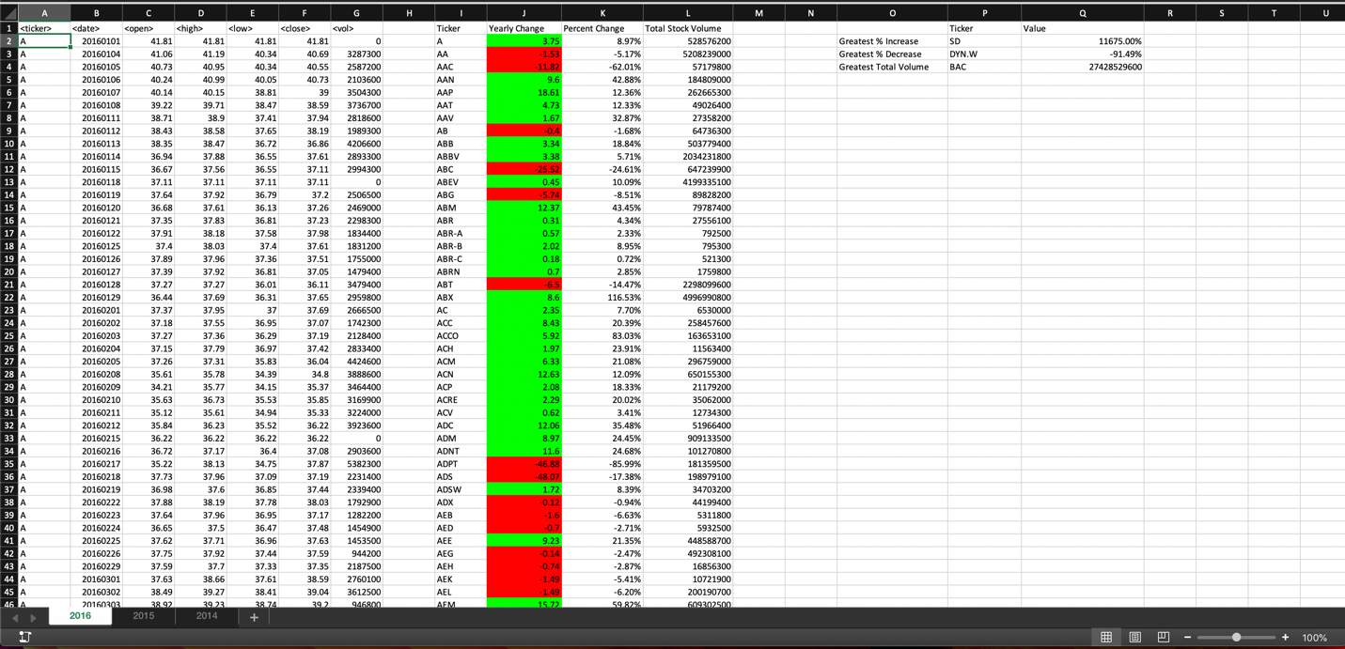

Tab - 2015

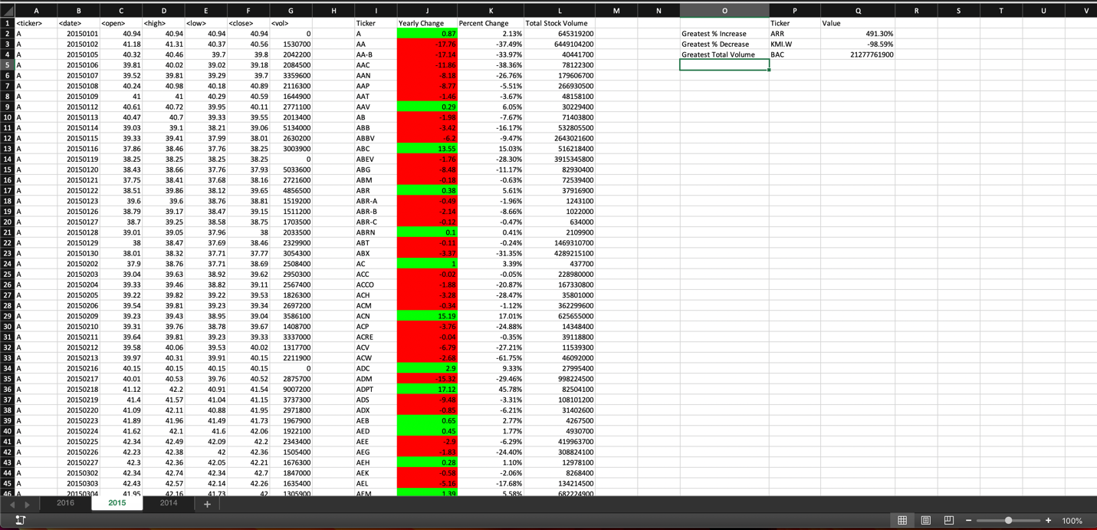

Tab - 2014

